GRADE 7 ACCELERATED · UNIT 2 · LESSON 2
Square Values and Square Roots
Worksheet 7A.02.02 ANSWER KEY

1. Label the three parts of the radical expression.
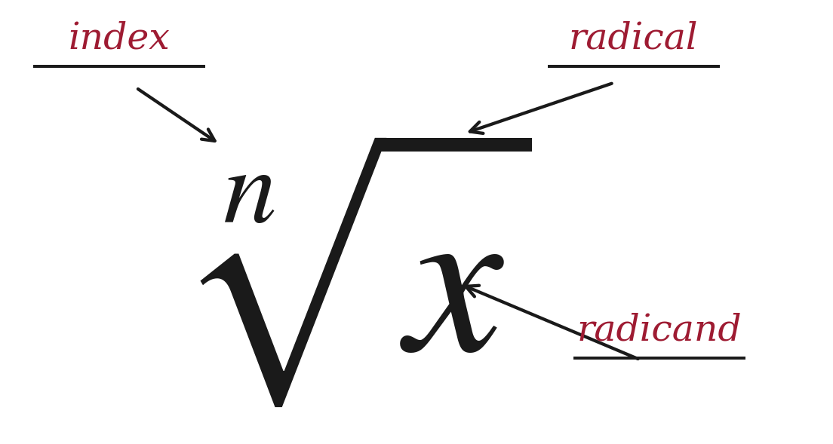
When no index is written, the index is 2 and the expression means a square root. Students meet an index of 3 tomorrow.
2. Fill in both boxes. They do not get the same answer, and the reason is the whole point of today.
The radical on its own | The equation
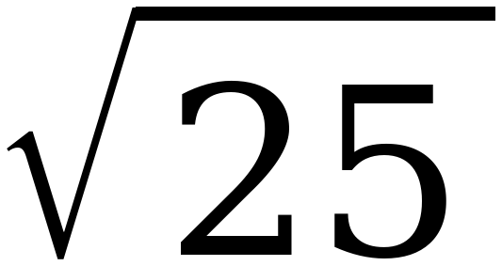 | x² = 25
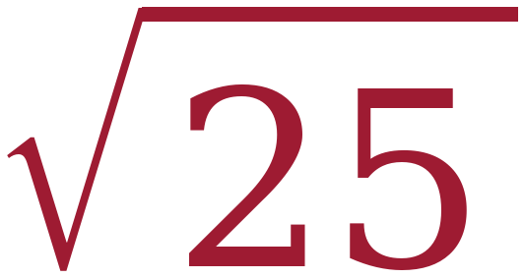 = 5 | x = ± = ±5

The radical symbol asks for one number — the positive one. The equation asks for every value of x that works, and there are two. Students who write ±5 in the left box have made the error this lesson exists to prevent.
For questions 3 through 6, find the value.
3. 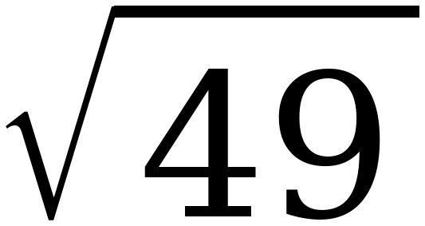
7 because 7 × 7 = 49

4. 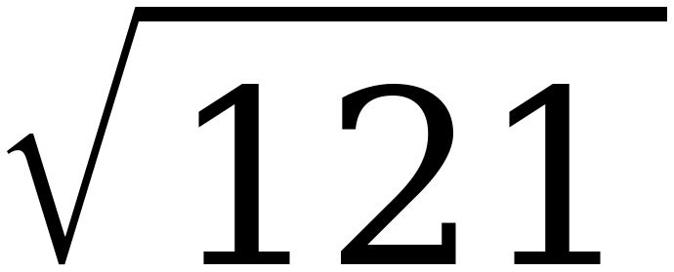
11 because 11 × 11 = 121

5. 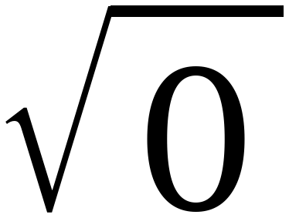
0 0 × 0 = 0, and 0 is the only number that works
Zero is the one radicand with a single square root rather than a positive and a negative one.

6. 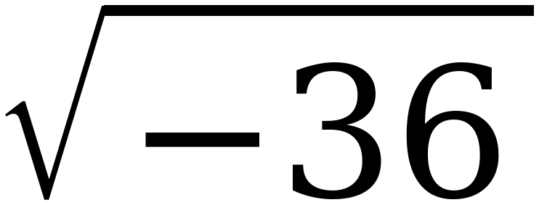
No real value.
Any real number times itself is positive or zero, so nothing squares to −36. Write “no real value,” not 0 and not −6.

For questions 7 through 10, find every real solution of the equation.
7. x² = 64
x = ±8 8 × 8 = 64 and (−8) × (−8) = 64

8. 144 = m²
m = ±12
The variable is on the right. Nothing changes.

9. x² = 0
x = 0
One solution, not two. This is the only value of p for which x² = p has a single answer.

10. y² = −49
No real solution.
Compare with question 6. Both are refused for the same reason, but one is a radical and one is an equation — students should be able to say which is which.

11. Select ALL of the values below that make x² = 81 true.
☒ | 9 | ☐ | 40.5
☒ | −9 | ☒ | 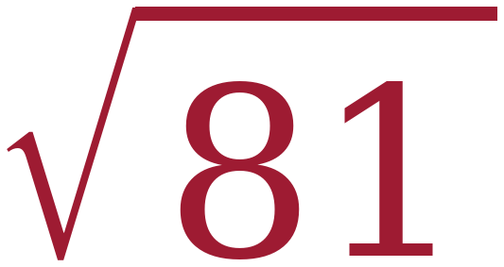
☒ | − | ☐ | 81²

Four of the six, and two of the four are the same numbers written a different way: √81 is 9, and −√81 is −9. That is the item this whole lesson is built for. 40.5 is 81 ÷ 2, the halving error; 81² is 6,561.
12. Nadia writes the statement below on her paper.
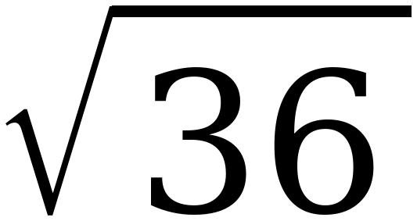 = ±6
Explain what is wrong with Nadia's statement, then write the two correct statements it should have been.
The radical symbol means the positive square root only, so the statement is false as written.
Correct statement 1: 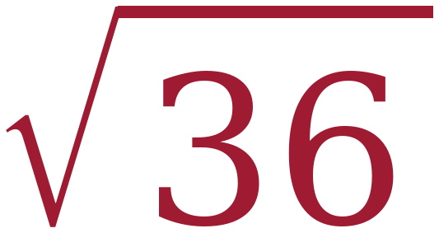 = 6
Correct statement 2: x² = 36 has two solutions, x = ±6
Nadia is not confused about the arithmetic — she knows both 6 and −6 square to 36. She has attached the ± to the wrong object. Say that out loud when you go over it.

